OPERATING Systems

**Name: Girish S Roll No.: AM.EN.U4AIE22044**

--------------------------------------------------------------------------

1. **Write shell scripts for the following**
   1. **To take your name, programme name and enrolment number as input from user and print it on the screen.  
      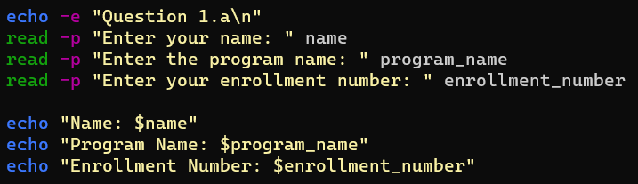  
      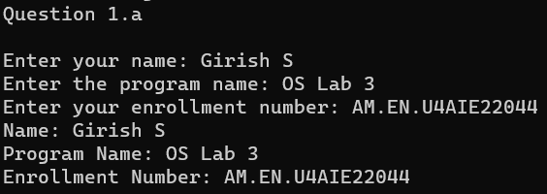**
   2. **To find the sum, the average and the product of four integers.  
      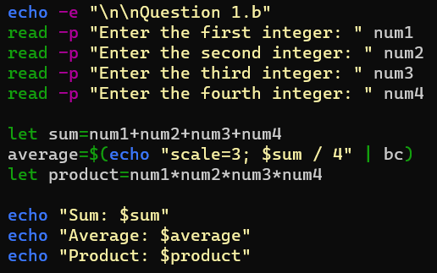**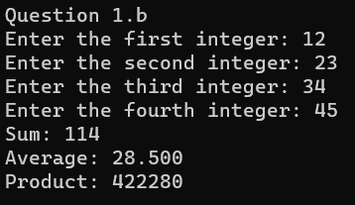
   3. **Write a program to check whether a number is even or odd.  
      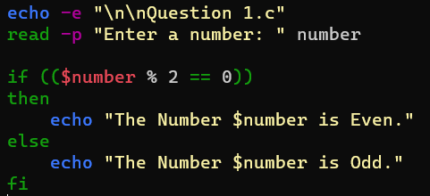  
      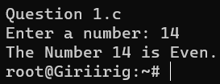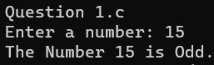**
   4. **To exchange the values of two variables.  
      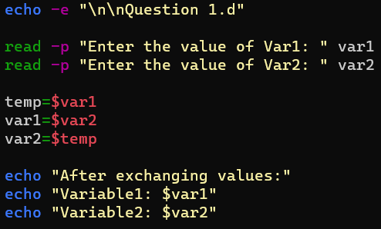  
      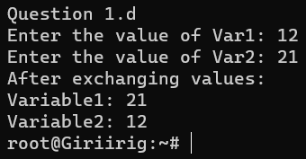**
   5. **To find the lines containing a number in a file.  
      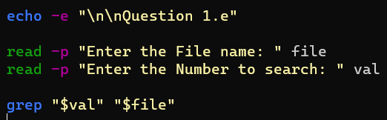  
      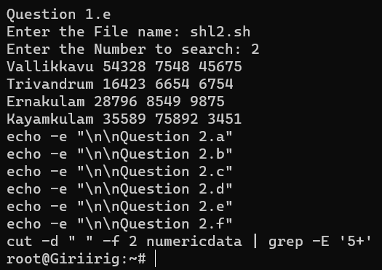**
   6. **To concatenate two strings and find the length of the resultant string.  
      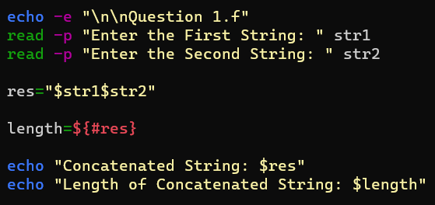  
      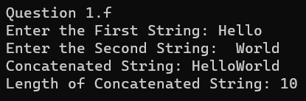**
   7. **To concatenate the contents of two files  
      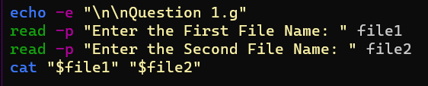  
        
      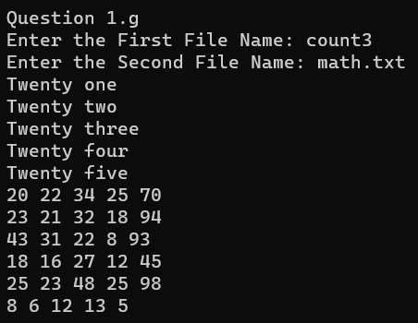**
   8. **Write a shell script that would wait 5 seconds and then display the time.  
      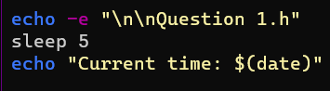  
      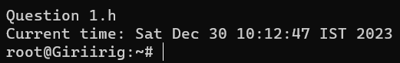**
2. **The length and breadth of a rectangle and radius of a circle are provided as user input. Write a shell script that will calculate the area and perimeter of the rectangle and the area and circumference of the circle.  
   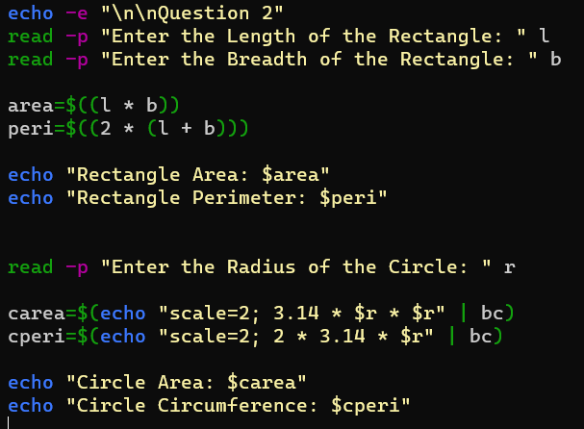  
     
   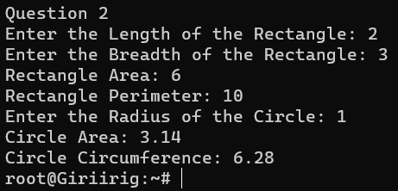**
3. **Write a menu driven shell program to read two numbers and print the results of all the arithmetic operations. ( + , - , * , / , % , ++ , -- )  
   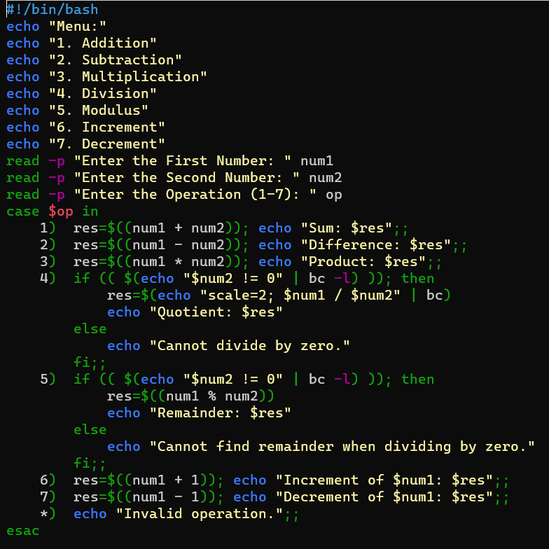  
     
   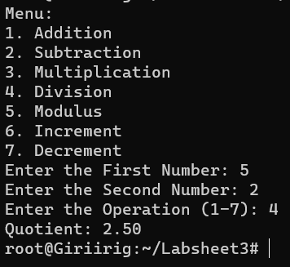**
4. **Write two separate shell scripts to find the factorial of a number using while statement and for statement  
   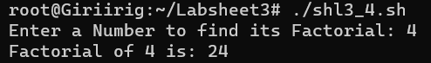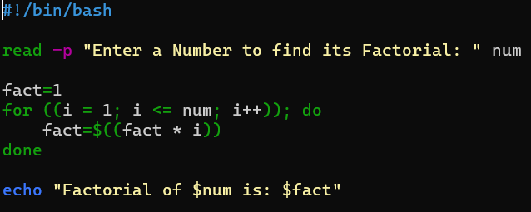**
5. **Given a file of numbers (one number per line), write a shell script that will find the lowest and highest number.  
   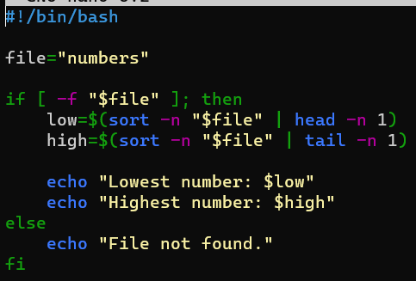  
   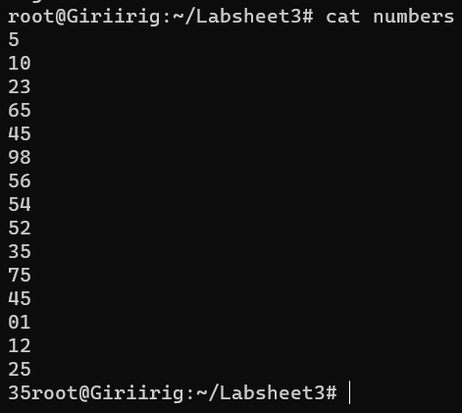  
   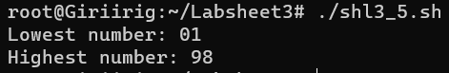**
6. **Write a shell program to read n numbers into an array and display the average of them.  
   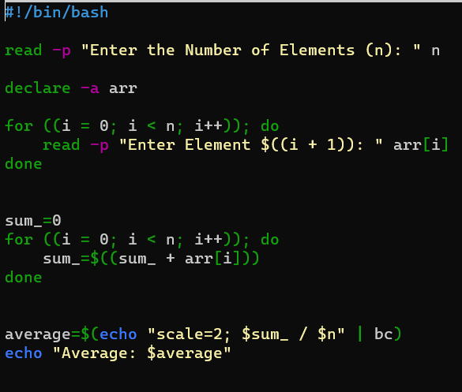  
     
   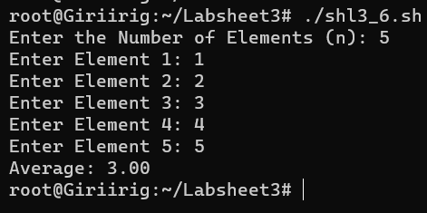**
7. **Write a shell program to print the following Patterns.  
   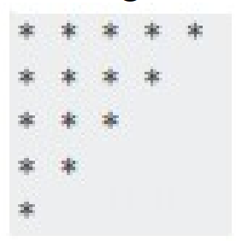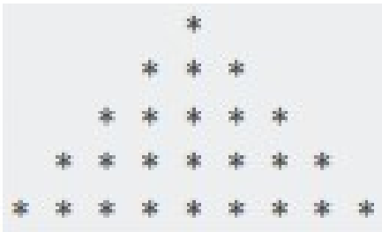  
   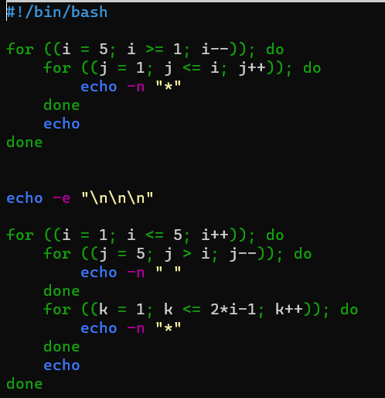  
   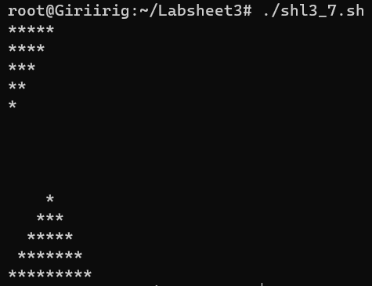**



1. **Write a shell program to read two matrices, add them and print the output matrix  
   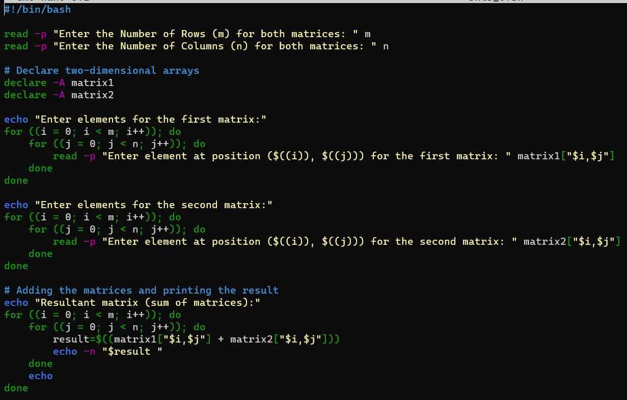  
   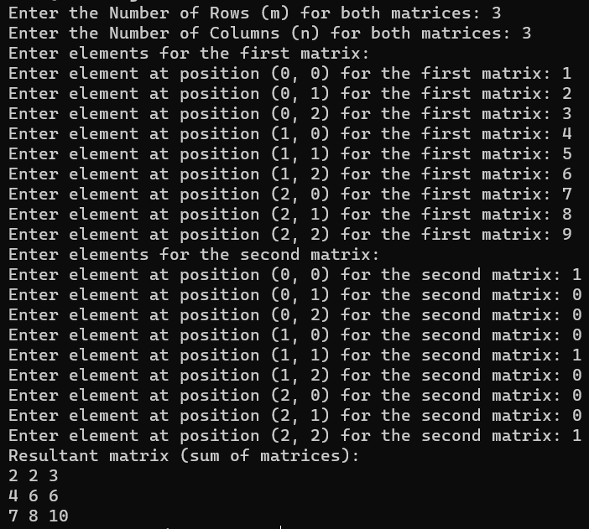**
2. **Write a program to read a matrix and print the transpose of it.  
   